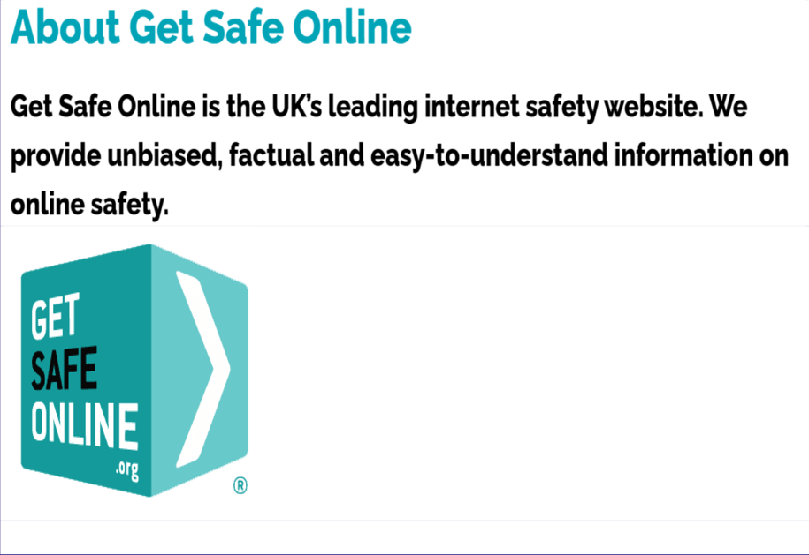
Information re Online safety…..
We just wanted to let you all know about GetSafeOnline.org which is a website designed to help people understand cyber security and stay safer online.
The website is full of excellent resources, some particularly useful ones are below. We think you may find these helpful.
Videos & Recorded Webinars
- Get AI Safe Online
- Gaming4Good: Safer Internet Webinar 2022
- Purchase Scams
- Computer Support Scams
- Phishing Scams
- Protect your PC
- Protect your ID
- Safe Social Networking
Spot the AI – Get help learning to spot the difference between AI and the real thing
Is it a Scam? – A simple way to check if something you have received is a scam or not
Check a Website – Determine whether a website is likely to be legitimate or a scam before you visit

Branch address
Notts UNISON (suite 12)
c/o Bizspace
Arnold Business Centre,
Brookfield Rd, Arnold,
Nottingham NG5 7ER
Tel: 0115 9810405
Email branch.office@nottsunison.org.uk
Web: www.nottsunison.org.uk

